Non-ideal circuit

We used the following circuit to figure out the potential losses of the circuit.

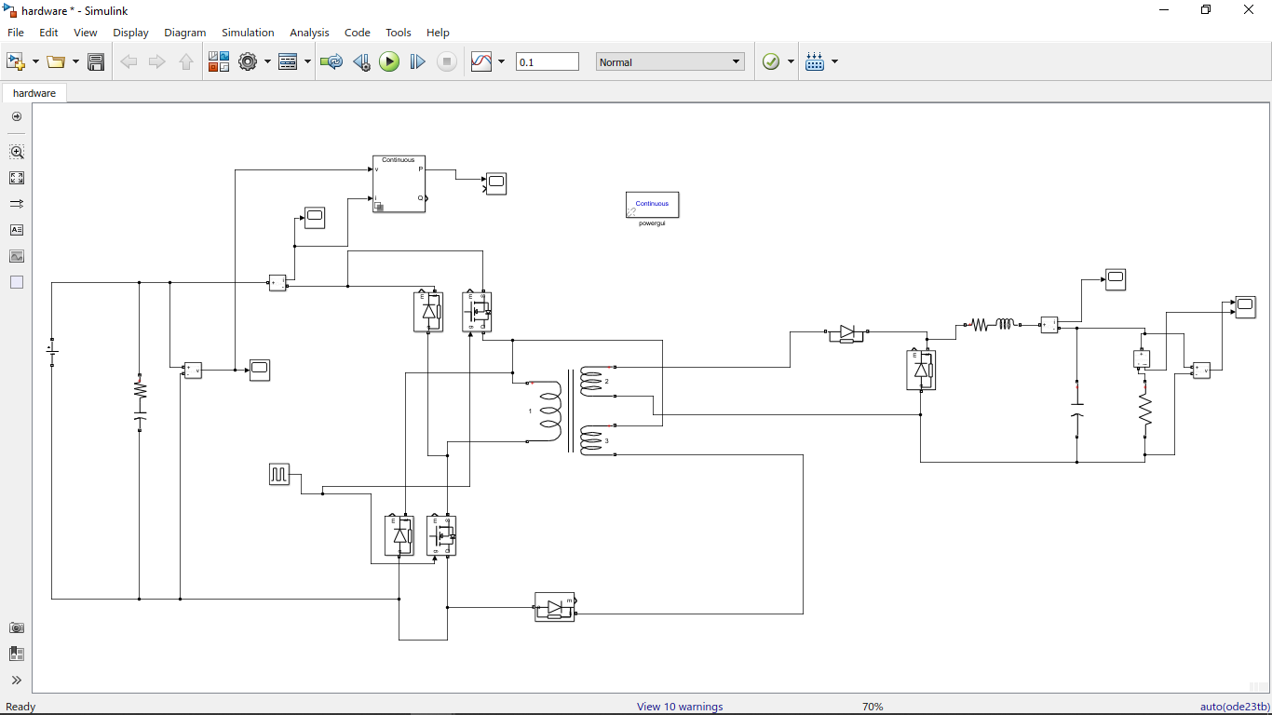

Figure: The non ideal circuit

Note the input capacitor. When we realized that the power supply in the lab was one-way, meaning that the whole concept of double switch was exploding on our hands. In order to overcome this, we simply added the input capacitor. The input capacitor stores the charges that we were trying to pump back into the source and seding them back to the circuit on the next cycle.

Here is the input current waveform:

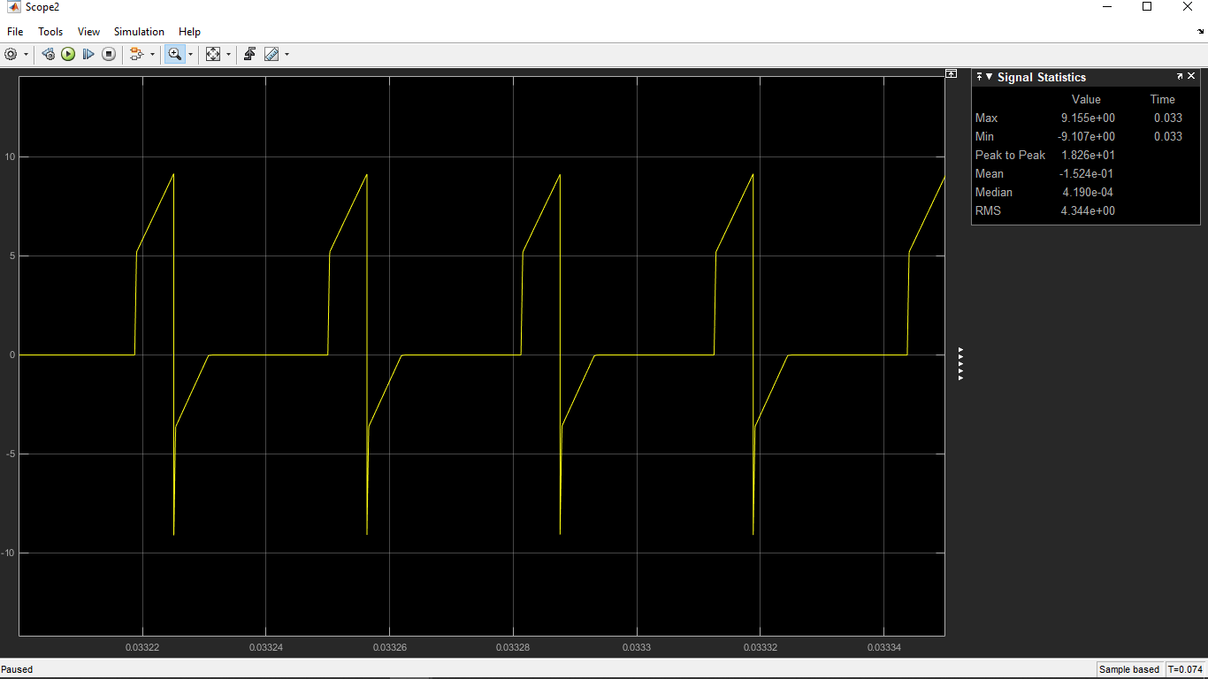

Figure: input current waveform

When we inspect the input current, we see that it was able to pump the charges back to source.

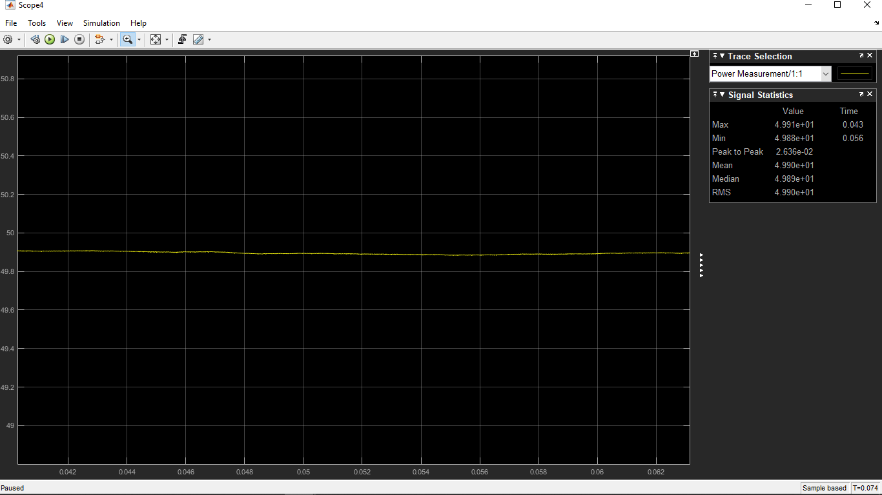

Figure: input power

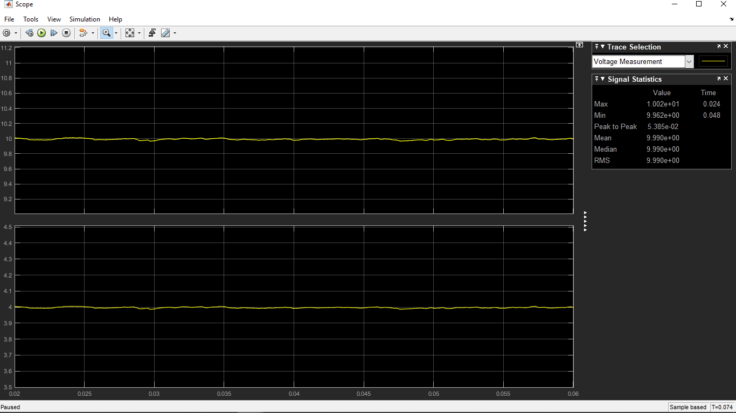

Figure: output voltage and current of the simulation

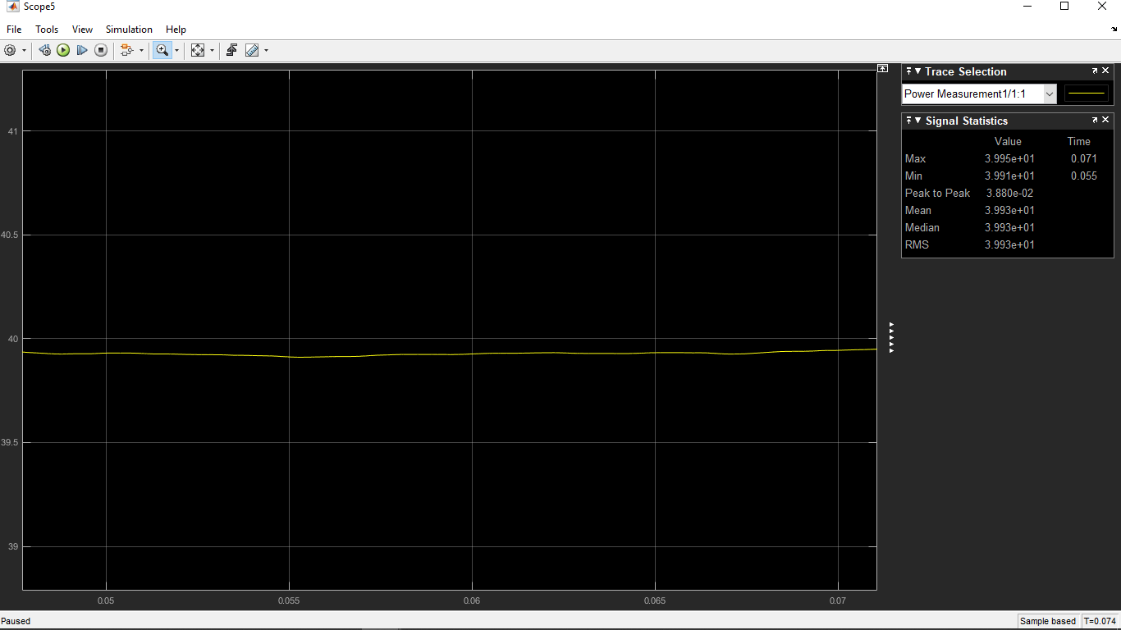

Figure: output power of the simulation

Upon inspecting the output, everything is normal and as we wanted. The efficiency is around %80, and life is good. However, when we snap back to reality, our converter’s efficiency was around %60. One of the reasons behind this was our snubbers were found with trial and error and is far from optimal. Also, the 47 ohm resistor at the gate of the MOSFET’s were quite high, and that was causing us to have a lot of switching losses on them. Lastly, even though we had the capacitor on the input, it is not an optimal solution and causing us some losses.

Here are the graphs of Vds of the MOSFETs ‘:

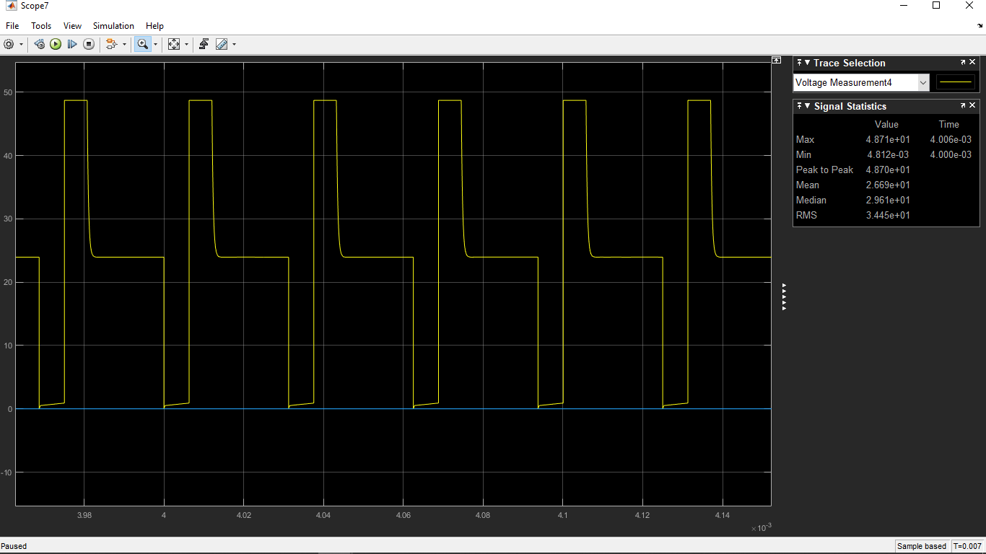

Figure: The mosfet Vds voltage waveform